MYSQL ASSIGNMENT 2 – QUERYING DATA
BY FATHIMA RESMIN F (69)

- Continue from the previous assignment (database & table creation with constraints)
Added previous tables and constraints
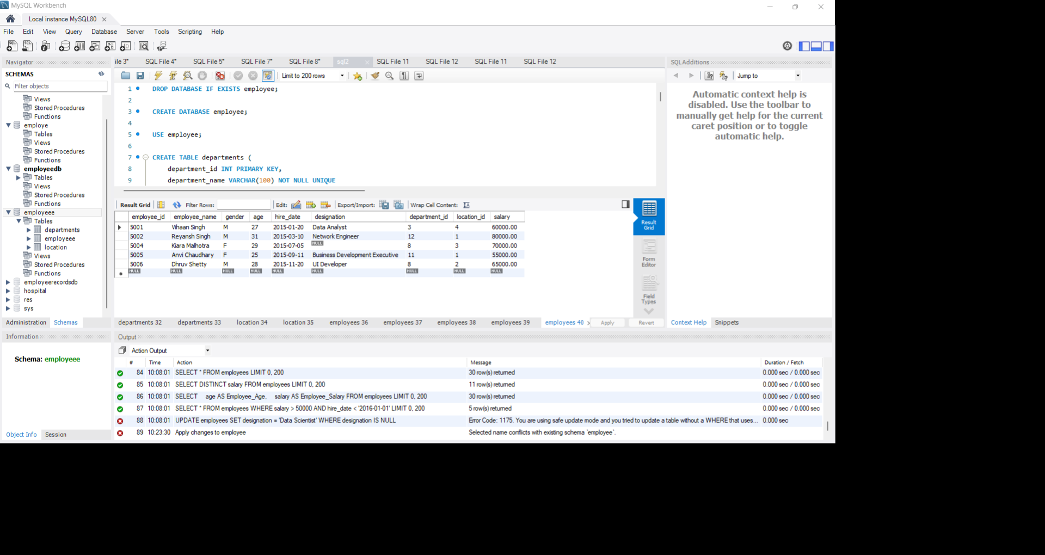

- Distinct Values:
⦿ A query to retrieve distinct salaries from the Employees table.
I add employee name with salary to easy to analyse
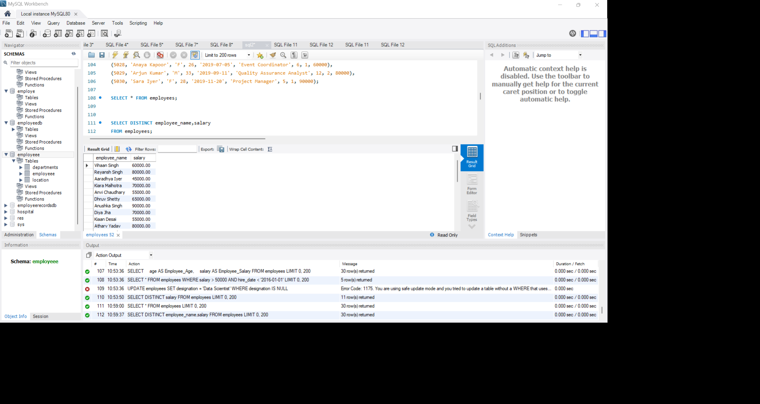

- Alias (AS):
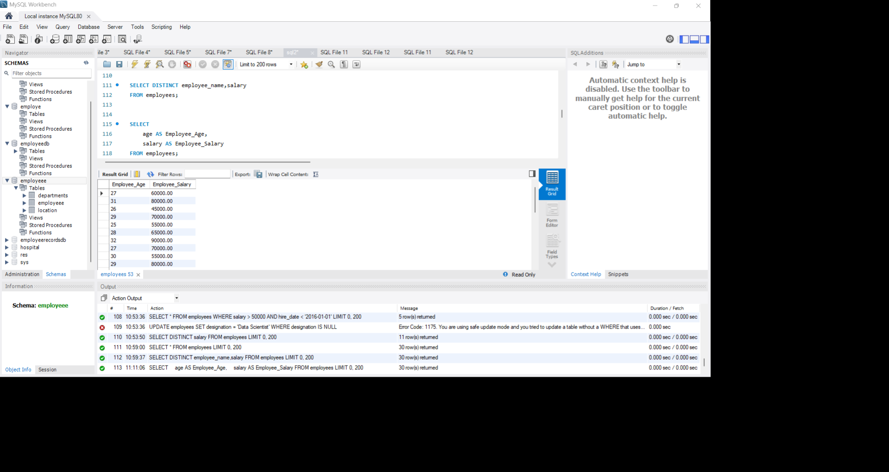
⦿ Provide aliases for the "age" and "salary" columns as "Employee Age" and "Employee Salary", respectively.

- Where Clause & Operators:
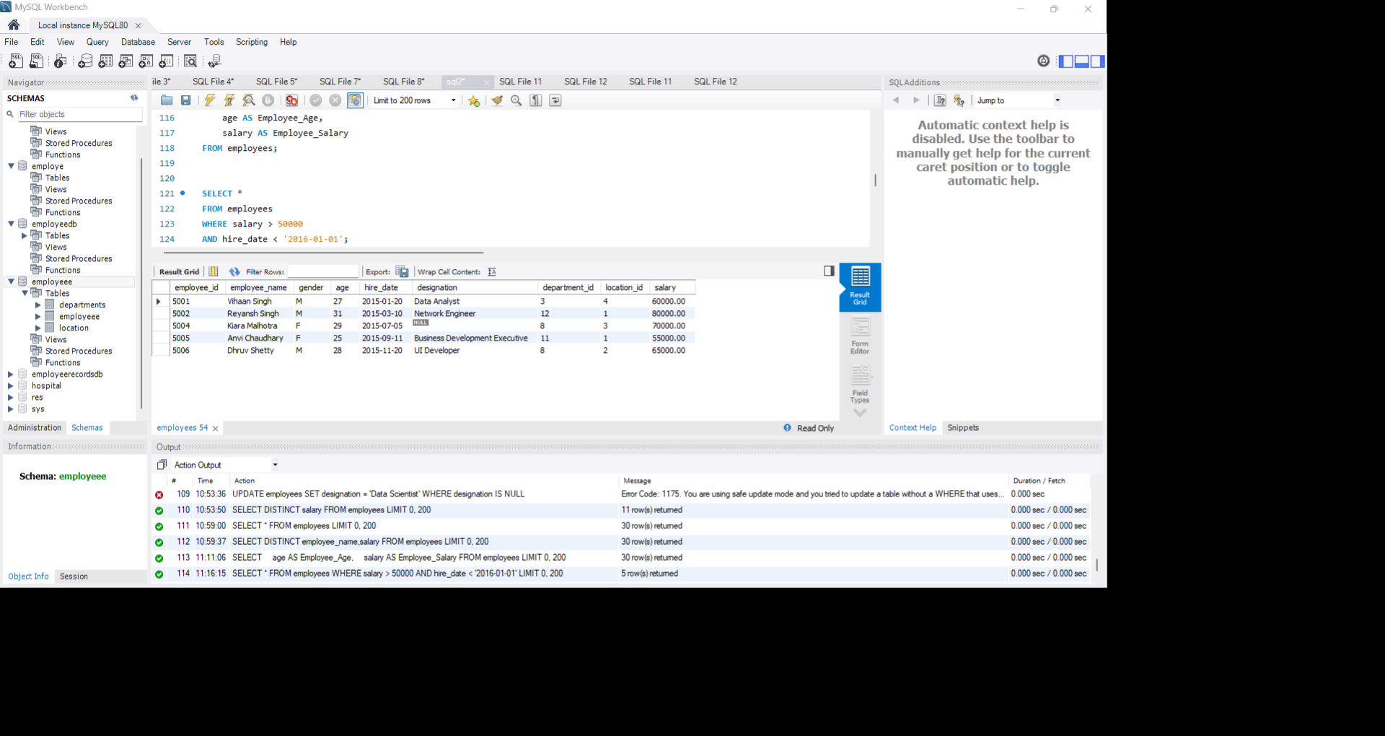
⦿ Retrieve employees with a salary greater than ₹50000 and hired before 2016-01-01.

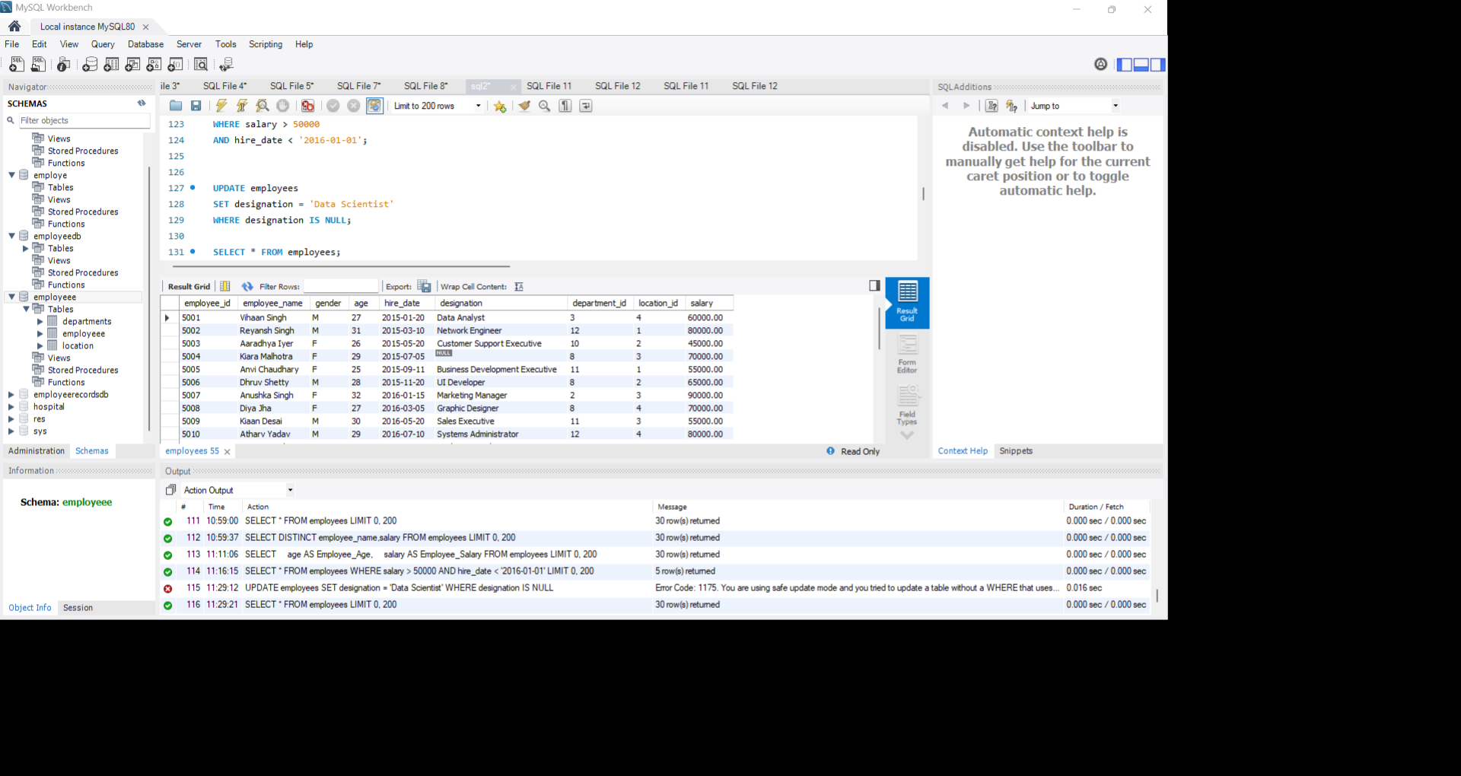
⦿ Find the employee whose designation is missing and fill it with "Data Scientist"

Sorting and Grouping Data:
1.ORDER BY:
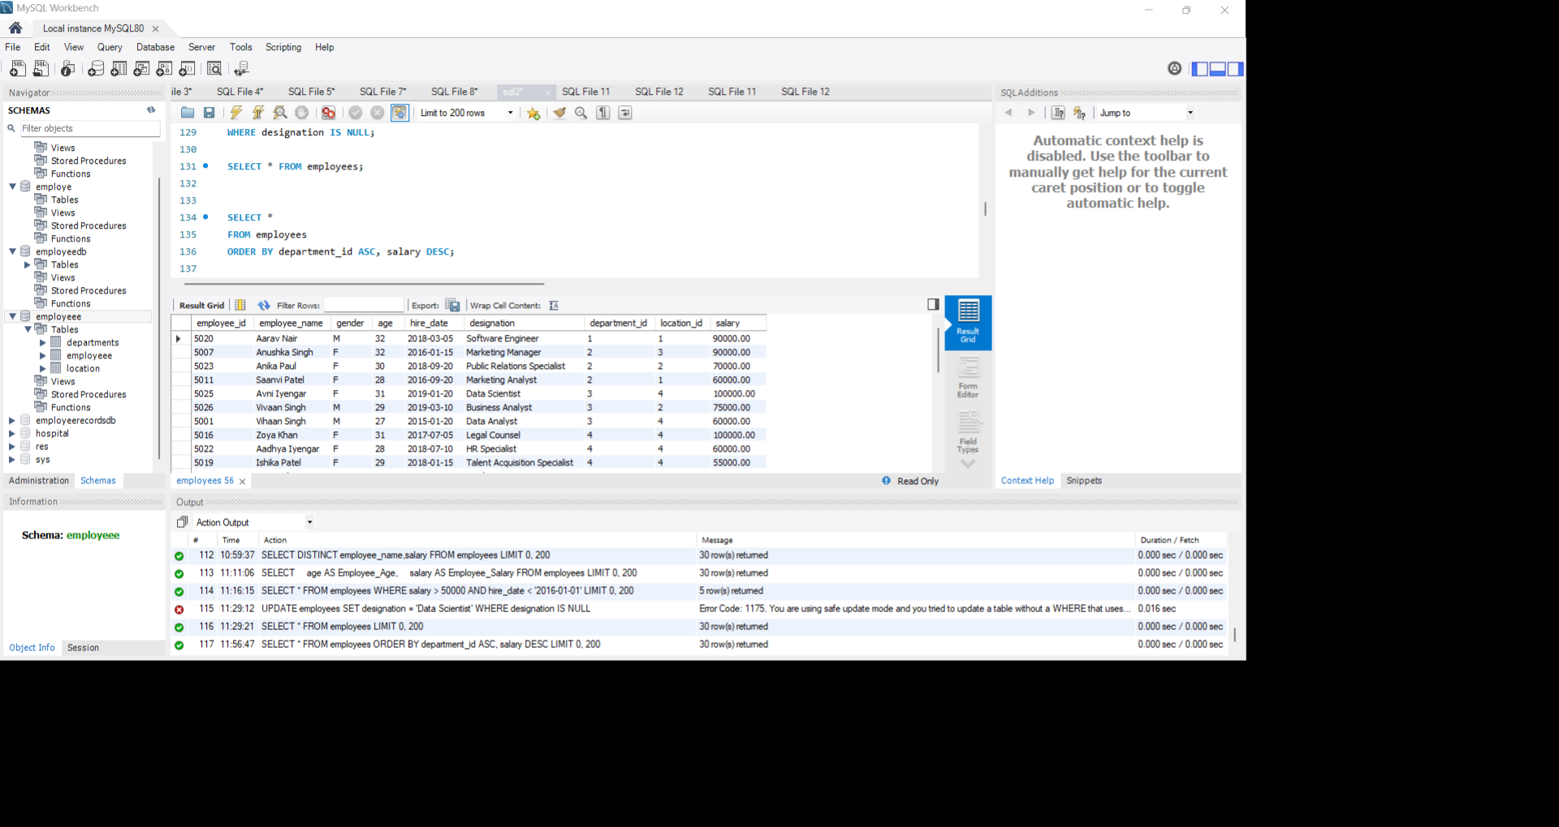
⦿ Find employees sorted by department ID in ascending order and salary in descending order.
2. LIMIT:
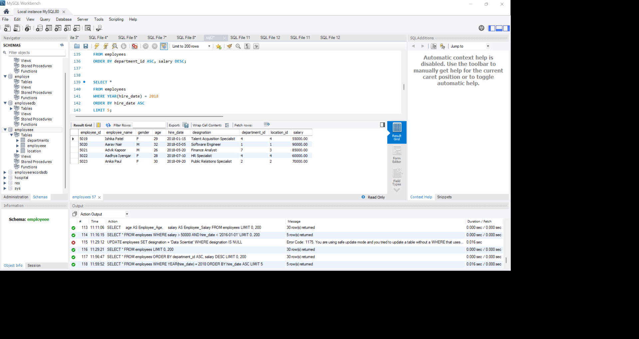
⦿ Display the first 5 employees hired in the year 2018

3. Aggregate Functions:
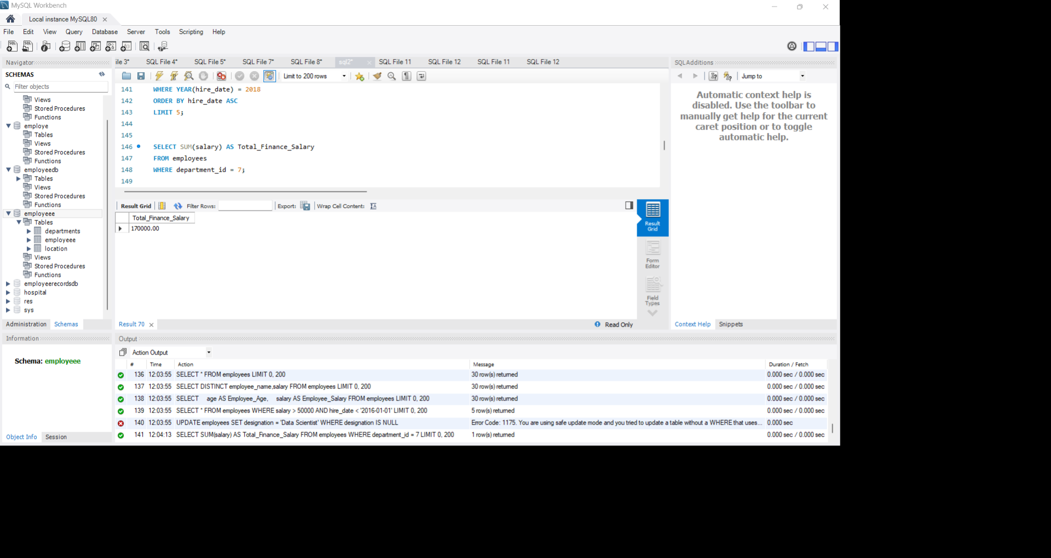
⦿ Calculate the sum of all salaries in the Finance department.

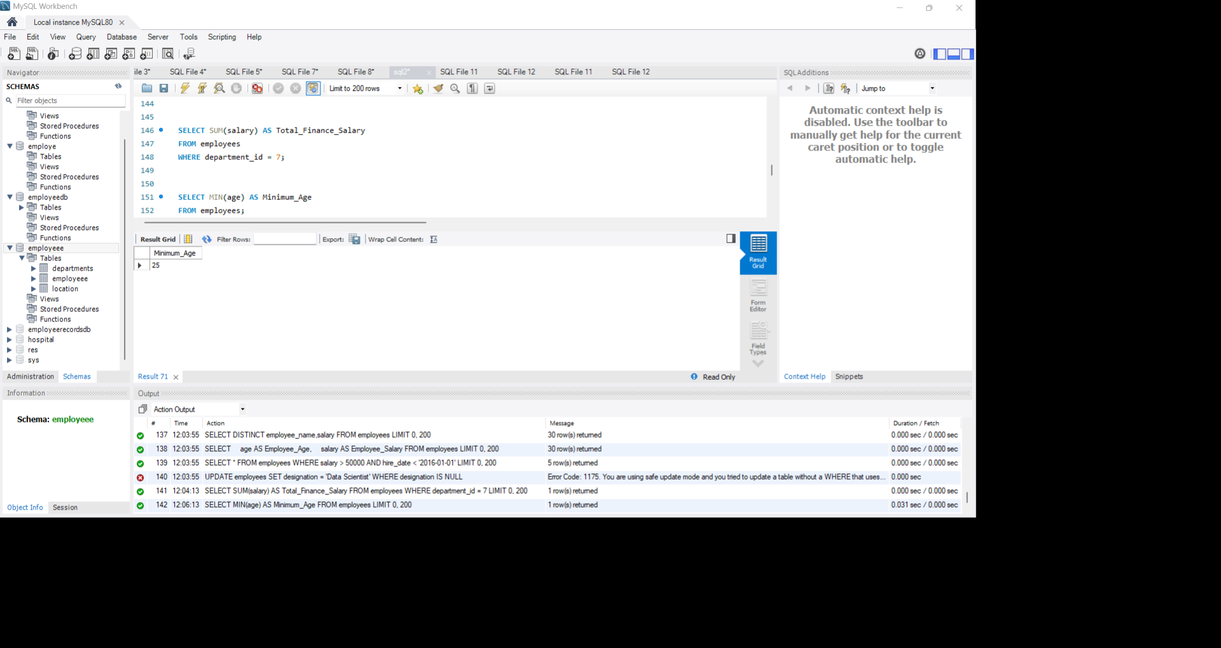
⦿ Find the minimum age among all employees

- GROUP BY:
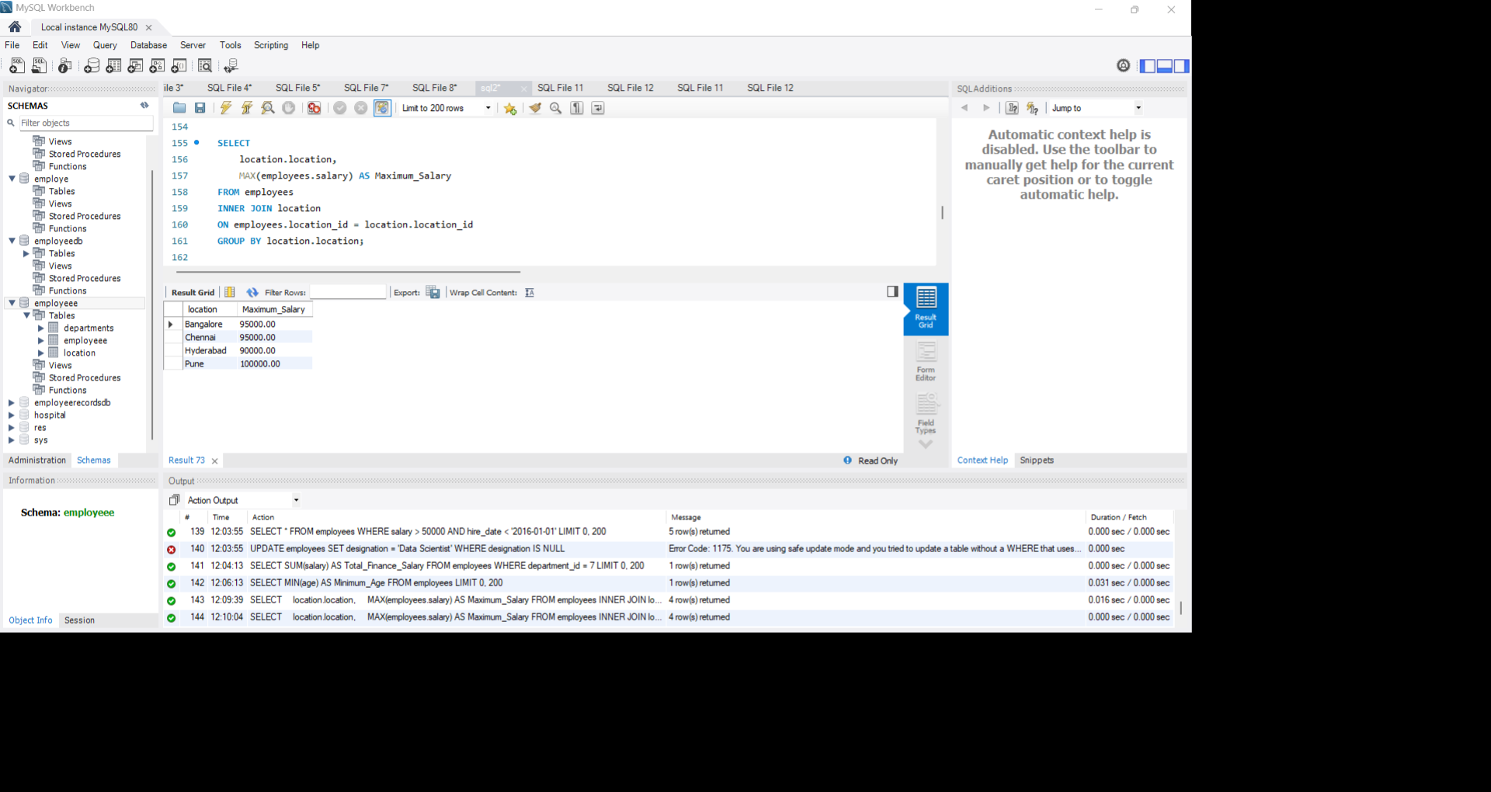
⦿ List the maximum salary for each location.

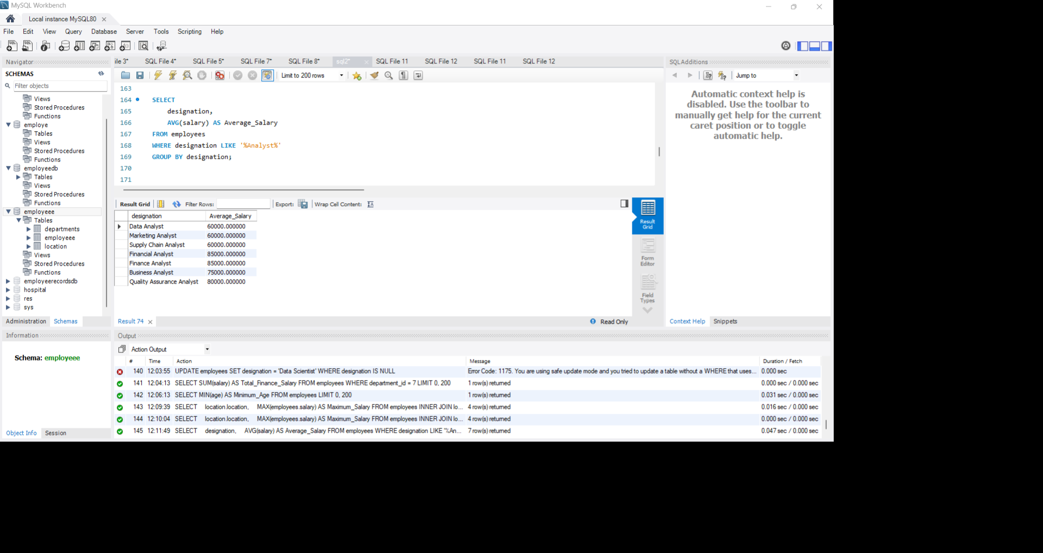
⦿ Calculate the average salary for each designation containing the word 'Analyst'.

- HAVING:
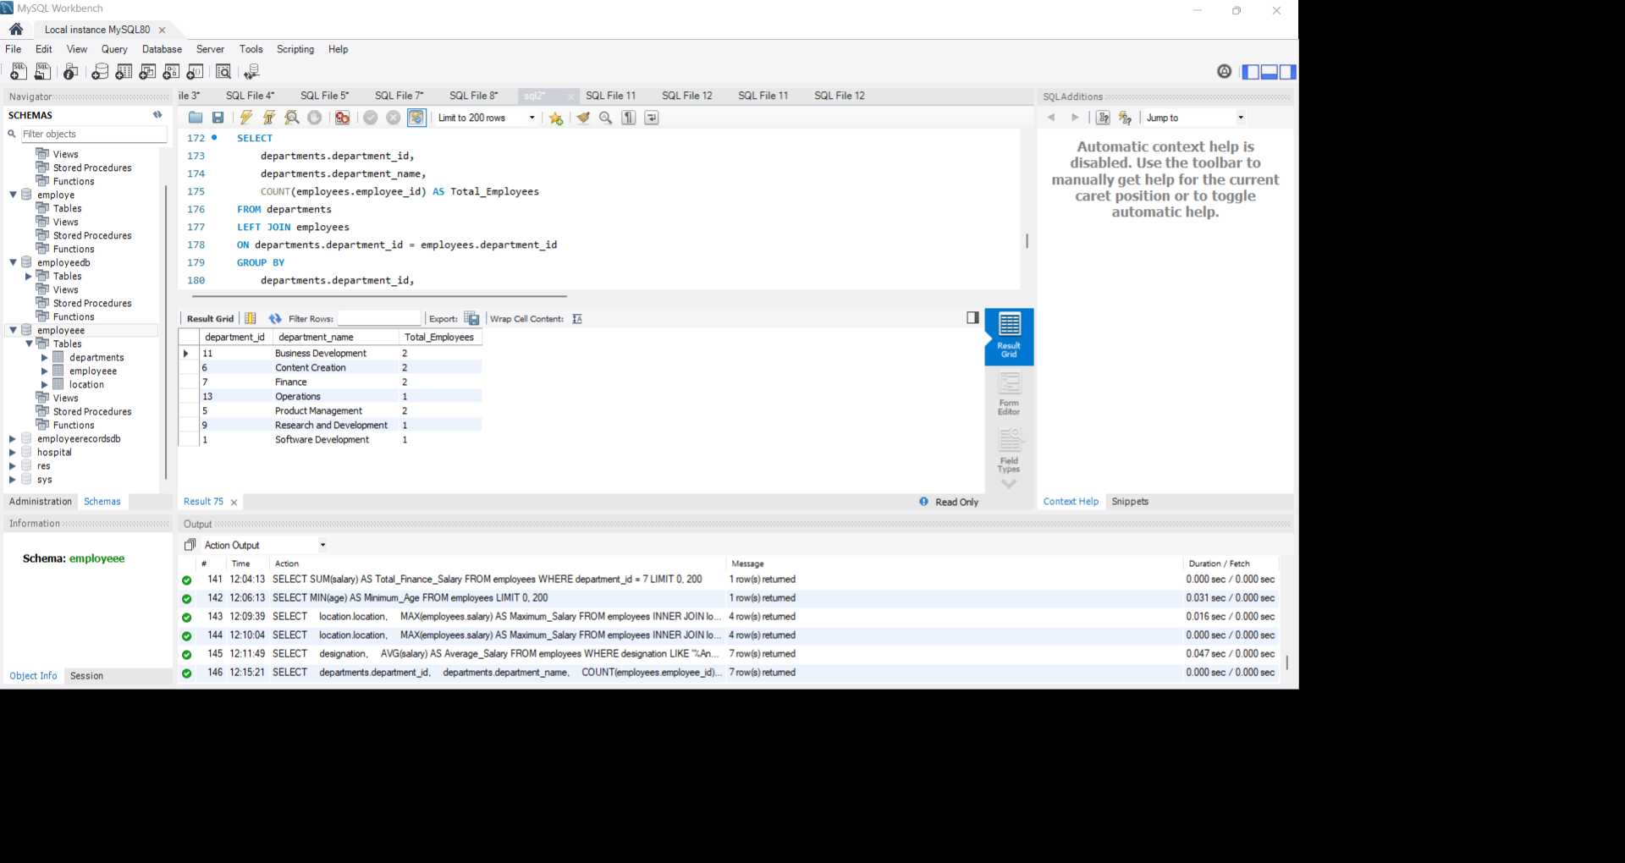
⦿ Find departments with less than 3 employees.

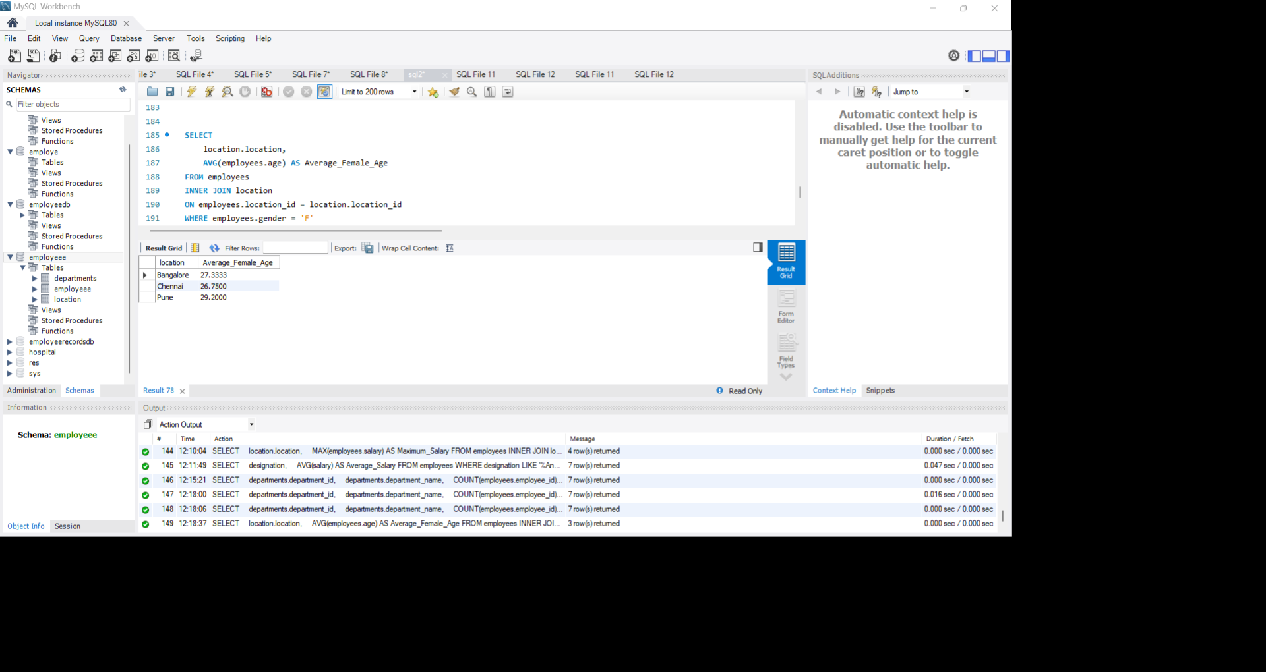
⦿ Find locations with female employees whose average age is below 30

Joins:
1. Inner Join:
⦿ List employee names, their designations, and department names where employees are assigned to a department.
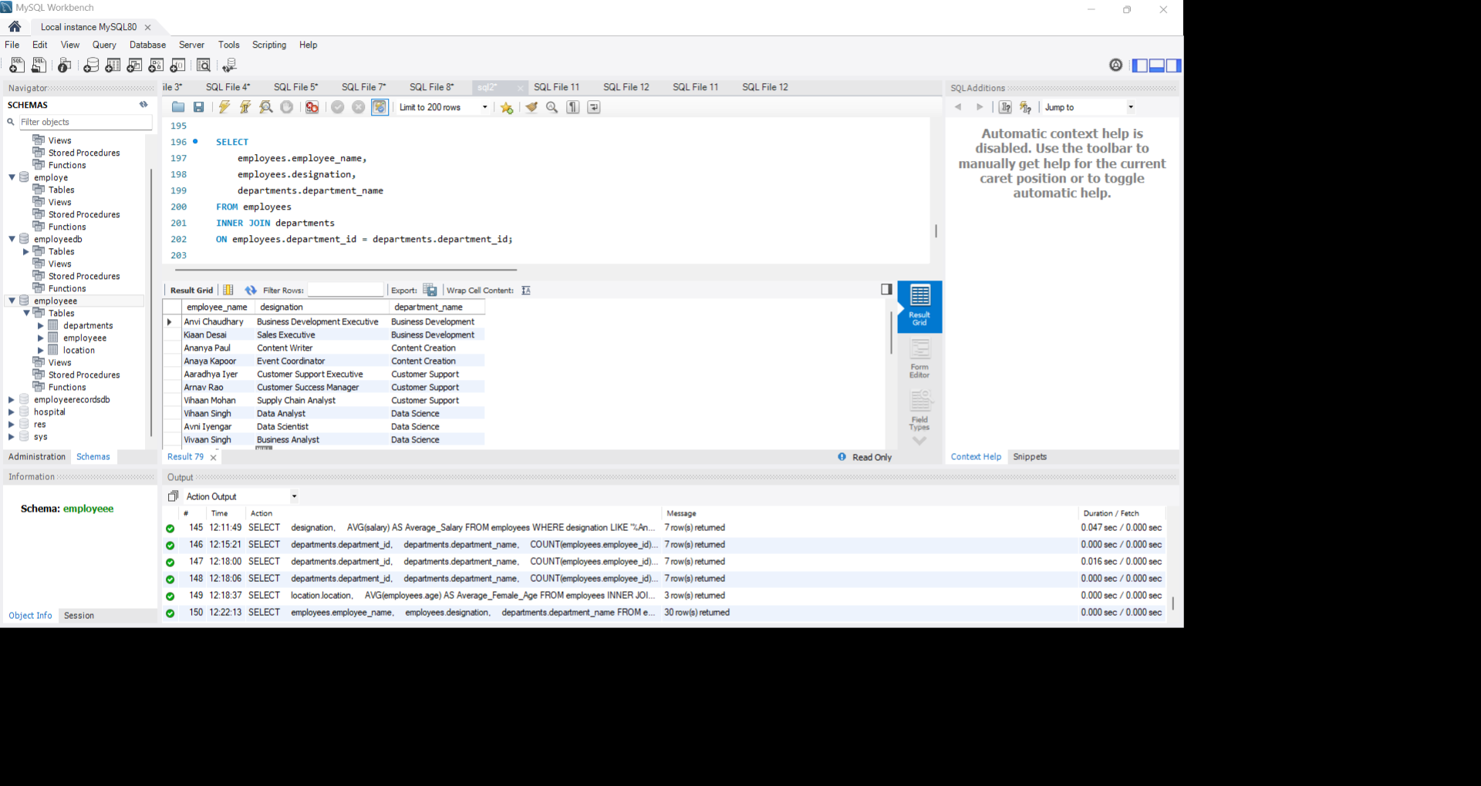

2. Left Join:
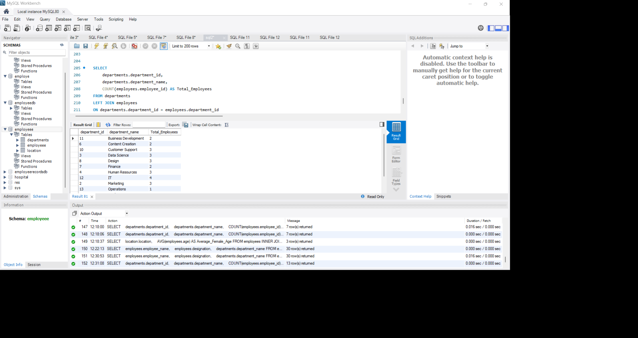
⦿ List all departments along with the total number of employees in each department, including departments with no employees.

3. Right Join:
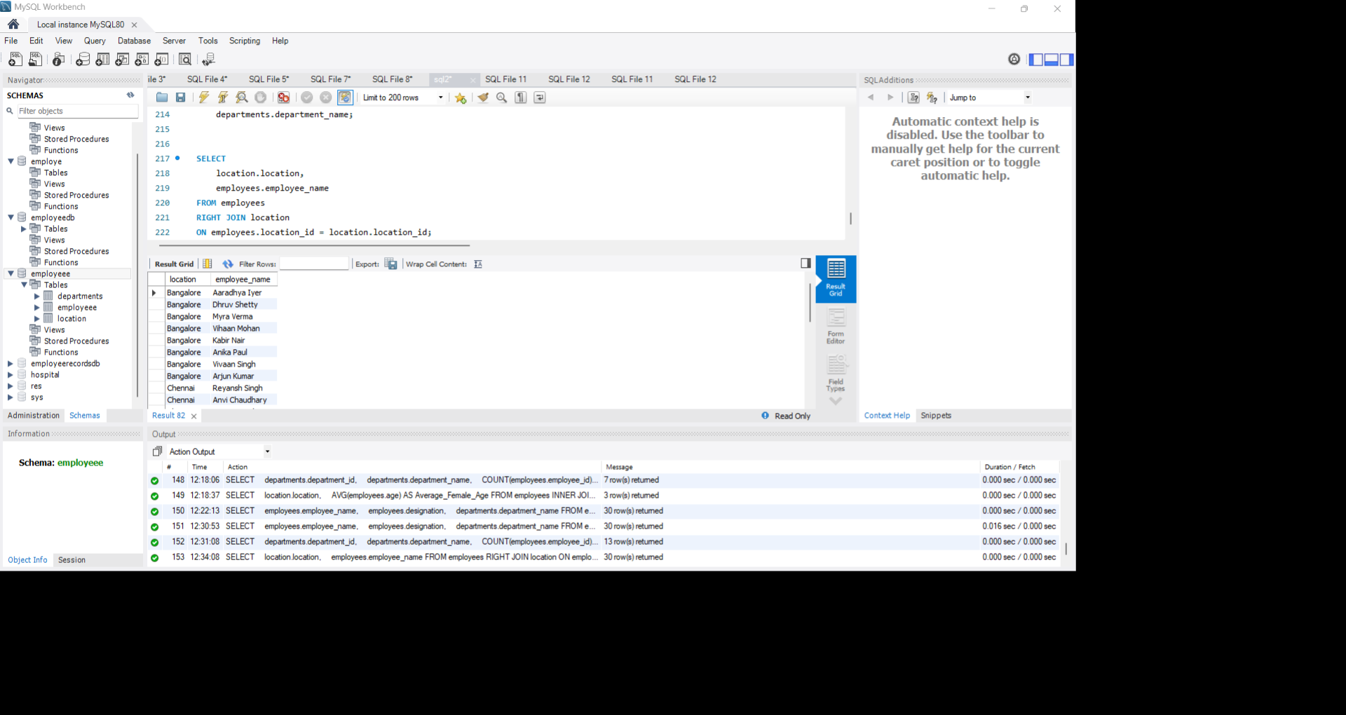
⦿ Display all locations along with the names of employees assigned to each location. If no employees are assigned to a location, display NULL for employee name.
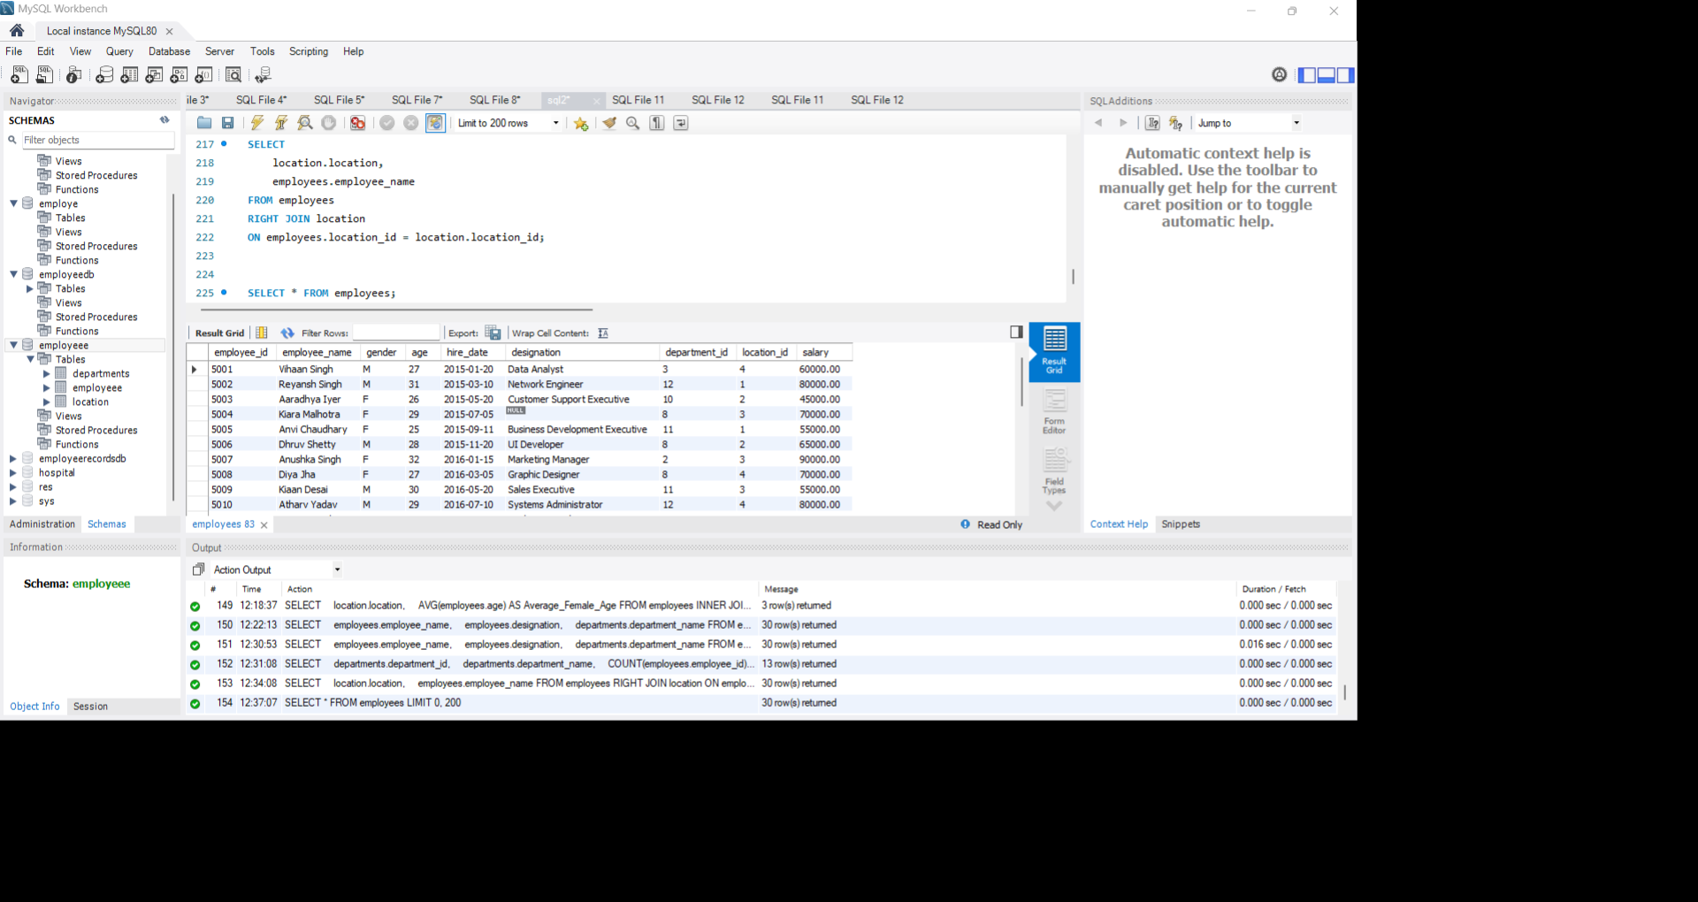
Employee table full view:

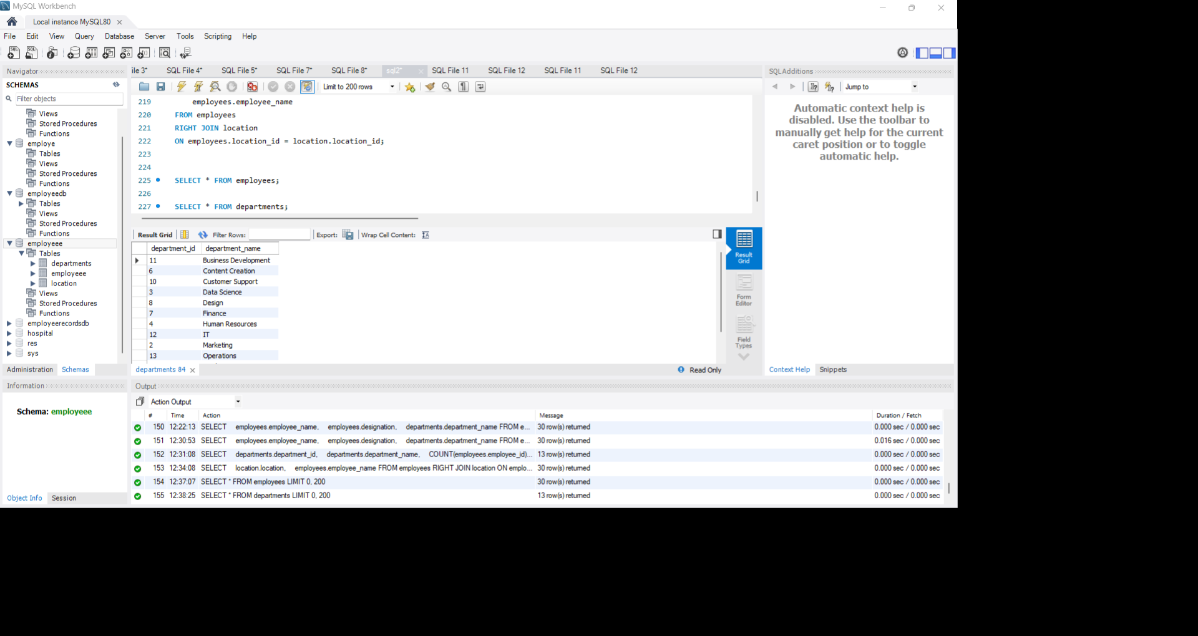
Department table:

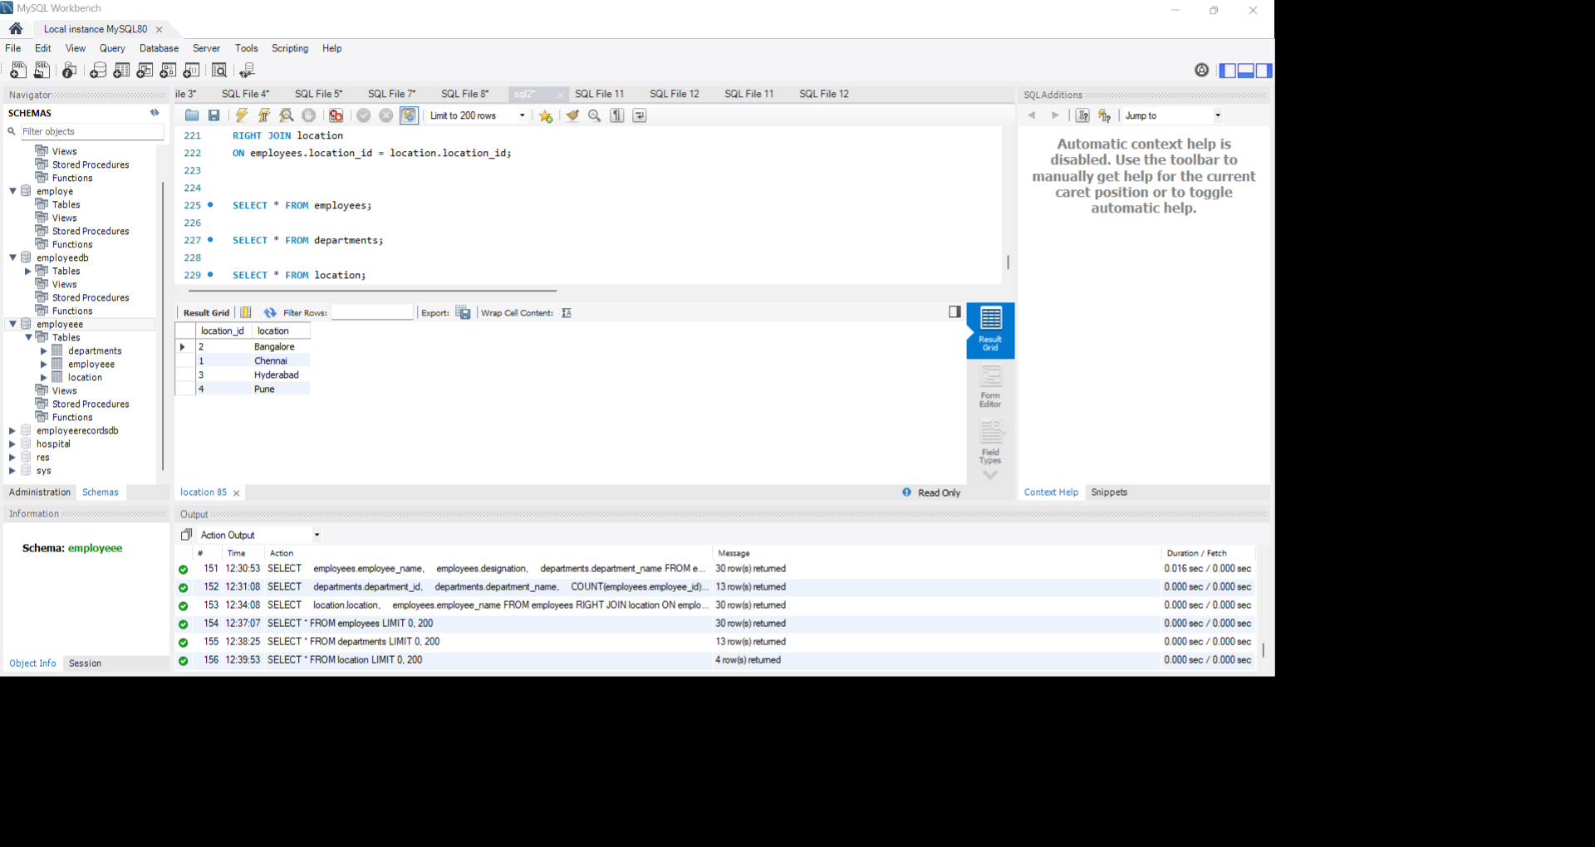
Location table:
Conclusion
Through this MySQL assignment, I learned how to create databases and tables, insert data, and retrieve information using SELECT queries. I practiced DISTINCT, ALIAS, WHERE, ORDER BY, LIMIT, aggregate functions, GROUP BY, HAVING, and different types of JOINs. I also learned how to update missing values and analyse employee data using SQL queries. This assignment improved my understanding of database management and helped me gain practical knowledge of MySQL.

